CENTRAL EAST EDUCATION DIVISION

2026 MSCE EXAMINATION
CHEMISTRY
PAPER I
Theory
(100 marks) Subject Number: M03/I
Wednesday, 25 March Time allowed: 2 hours (08: 00am – 10: 00am )
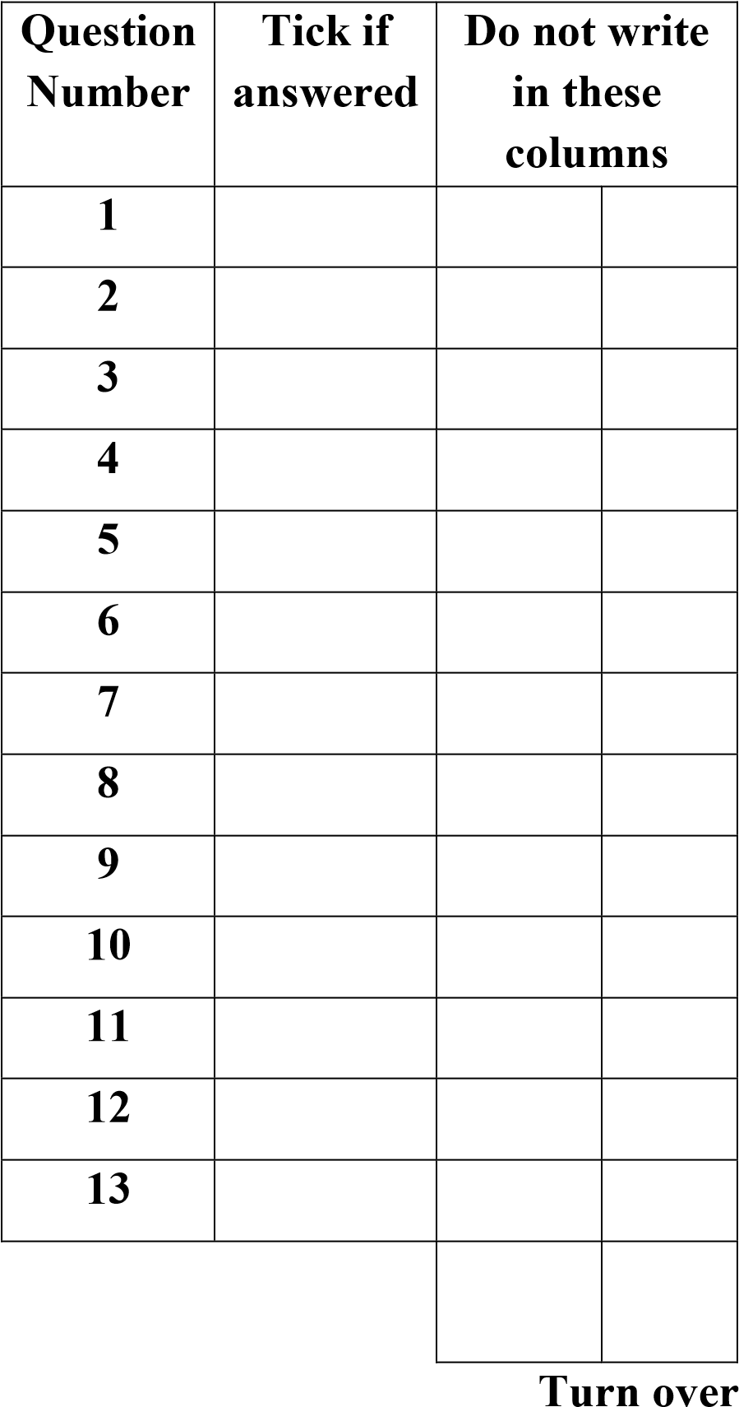
Instructions
- This paper contains 13 printed pages. Please check.
- This paper contains two sections A and B. In Section A there are short answer questions while in Section B there are restricted essay questions.
- Answer all the thirteen questions in the spaces provided.
- Write the name of your school and examination number in the spaces provided.
- The maximum number of marks for each answer is indicated against each question.
- In the table provided on this page, tick against the number of the question you have answered.
- Hand in your Paper at the end of the examination

© CEED 2026
Section A (70 marks)
Answer all the ten questions in this section in the spaces provided for each question
- a. Give an example of waste that can be disposed in fume chamber.
_____________________________________________________________
(1 mark)
b. Describe the test to determine the presence of hydrogen gas.
__________________________________________________________________________________________________________________________ (2 marks)
c. Mention any one reagent that can be used to identify the aqueous cation
_____________________________________________________________
(1 mark)
- a. Mention any two similarities between diamond and silicon dioxide
__________________________________________________________________________________________________________________________
(2 marks)
b. Explain why graphite conducts electricity
____________________________________________________________________________________________________________________________________________________________________________________________________________________________________________________
(2 marks)

c. Figure 1 below shows a co-ordinate bond.
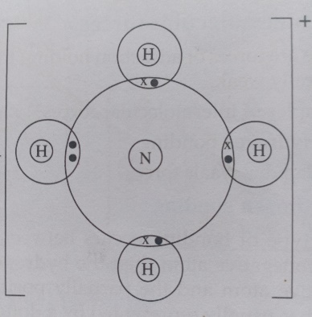
- By using an arrow identify the dative bond. (1 mark)
- Explain the formation of the bond formed.
________________________________________________________________________________________________________________________________________________________________________
(2 marks)
d. Mention an alloy that is used for making surgical instruments
_____________________________________________________________
(1 mark)
3 a. Study the organic compounds A, B, C and D and questions that follow:
A: CH₃COCH₃ B: CH₃COOCH₂CH₃
C: CH₃COOH D: CH₃CH₂OH
b. Name the compounds A and B
A_________________________________________________________
B_________________________________________________________
(2 marks)

c. Give any two uses of compound D
______________________________________________________________________________________________________________________
(2 marks)
d. Describe how you can distinguish compound C and D
____________________________________________________________________________________________________________________________________________________________________________________________________________________________________________
(4 marks)
4 a. Define a weak base
__________________________________________________________________________________________________________________________
(1 mark)
b. Below is a chemical equation
HCl_{(aq)} + NH_{3(aq)} NH₄⁺_{(aq)} + Cl⁻_{(aq)}
- Identify the two conjugate acid-base pairs
_____________________________________________________________
_____________________________________________________________
(2 marks)
(ii) Define the term ‘amphoteric oxides’
____________________________________________________________________________________________________________________________
(1 mark)

(iii) Give any two examples of amphoteric oxides
____________________________________________________________________________________________________________________________
(2 marks)
5 a. Mention any two conditions for rusting
____________________________________________________________________________________________________________________________
(2 marks)
b. Explain how each of the following prevents rusting of iron
i. tin plating
____________________________________________________________________________________________________________________________
(2 marks)
ii. galvanizing
____________________________________________________________________________________________________________________________
(2 marks)
c. Explain how a precipitation reaction can be used in treatment of industrial effluents
__________________________________________________________________________________________________________________________________________________________________________________________
(3 marks)

6a. Mention any two physical properties of water
____________________________________________________________________________________________________________________________
(2 marks)
b. Give any two advantages of hard water
____________________________________________________________________________________________________________________________
(2 marks)
c. Give any one importance of the ozone layer
______________________________________________________________
(1 mark)
d. Describe how burning of fossil fuels contributes to global warming
____________________________________________________________________________________________________________________________
(2 marks)
e. Give any one example of non-biodegradable waste
____________________________________________________
(1 mark)
7a. Define ‘empirical formula’
________________________________________________________________________________________________________________________________
(1 mark)

b. The empirical formula of a compound is CH₂O and the molecular mass is 180g/mol. Calculate the molecular formula of the compound. (RAM of C = 12, H = 1 and O = 16). (4 marks)

c. Calculate the emf of an electrochemical cell involving
Zn_{(s)} | Zn²⁺ _{(aq)} || Cu²⁺_{(aq)} | Cu _{(s)} given that
Cu²⁺_{(aq)} + 2e Cu_{(s)} Eº = + 0.34V
Zn²⁺_{(aq)} + 2e Zn_{(s)} Eº = - 0.76V

(2 marks)

8a. Define polymers
____________________________________________________________________________________________________________________________________
(1 mark)
b. Give any two examples of natural polymers.
____________________________________________________________________________________________________________________________________
(2 marks)
c. Describe any two differences between thermosoftening and thermosetting plastics
________________________________________________________________________________________________________________________________________________________________________________________________________________________________________________________________________
(4 marks)
9a. Mention any two raw materials for manufacturing of nitric acid by Ostwald process
____________________________________________________________________________________________________________________________________
(2 marks)
b. Give any two uses of nitric acid.
____________________________________________________________________________________________________________________________________
(2 marks)
c. Outline the three stages of manufacturing of sulphuric acid by contact process
______________________________________________________________________________________________________________________________________________________________________________________________________
(3 marks)
10a. Consider the equation below:
C_{(S)} + O_{2(g)} CO₍₂₎ H = -393.5kJ
- State whether the reaction is exothermic or endothermic.
__________________________________________________________ 1 mark
- Draw the energy level diagram for the reaction.

(3 marks)
b. Mention any two natural sources of alkanoic acid
________________________________________________________________________________________________________________________________
(2 marks)
Section B (30 marks)
Answer all the three questions in this section in the spaces provided
11. a. With the aid of an equation explain how sodium carbonate (Na₂CO₃) can be used to remove permanent water hardness.

________________________________________________________________________________________________________________________________________________________________________________________________________________________________________________________________________________________________________________________________________________________________________________________________________________________________________________________________________________________________________
(5 marks)

b. With an aid of a diagram describe how an iron spoon can be coated with copper metal

______________________________________________________________________________________________________________________________________________________________________________________________________
______________________________________________________________________________________________________________________________________________________________________________________________________
(5 marks)
12. a With an aid of a diagram and equation explain how ethanol can be prepared in the laboratory by fermentation of sugars

____________________________________________________________________________________________________________________________________________________________________________________________________________________________________________________________________________________________________________________________________________________________________________________________________________
(5 marks)
b. Describe an experiment that can be conducted to investigate the effect of impurities on boiling point of water
________________________________________________________________________________________________________________________________________________________________________________________________________________________________________________________________________________________________________________________________________________________________________________________________________________________________________________________________________________________________________________________________________________
(5 marks)

13. Describe an experiment that can be done to prepare barium sulphate as a insoluble salt
________________________________________________________________________________________________________________________________________________________________________________________________________________________________________________________________________________________________________________________________________________________________________________________________________________________________________________________________________________________________________________________________________________________________________________________________________________________________________________________________________________________________________________________________________________________________________________________________________________________________________________________________________________________________________________________________________________________________________________________________________________________________________________________________________________________________________________________________________________________________________________________________________________________________________________________________________________________________________________________________________________________________________
(10 marks)
END OF QUESTION PAPER
NB: This paper contains 13 printed pages.

